Image | 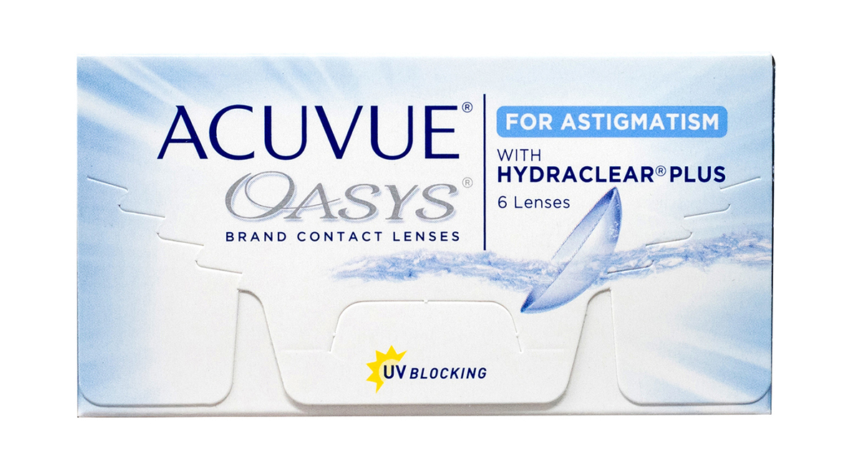
Brand | GUCCI
Model Name | \acuvue-oasys-astigmatism3
Price | RS 2500
PRODUCT DETAILS

